

**JSC “Kazakh British Technical University”**

**Faculty of Information Technology**

**Microprocessor Control Systems**

**Laboratory Work #3**

**Prepared by: Maratuly Temirbolat**

**Almaty 2021**

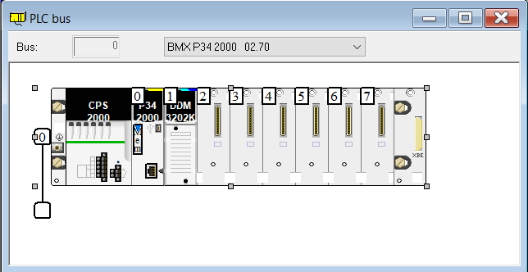

**Task 3.2**

It is necessary to implement the task of switching traffic light colors when a button is pressed without using the case..of..end_case construct, using the IF..THEN..ELSE..END_IF condition statement.

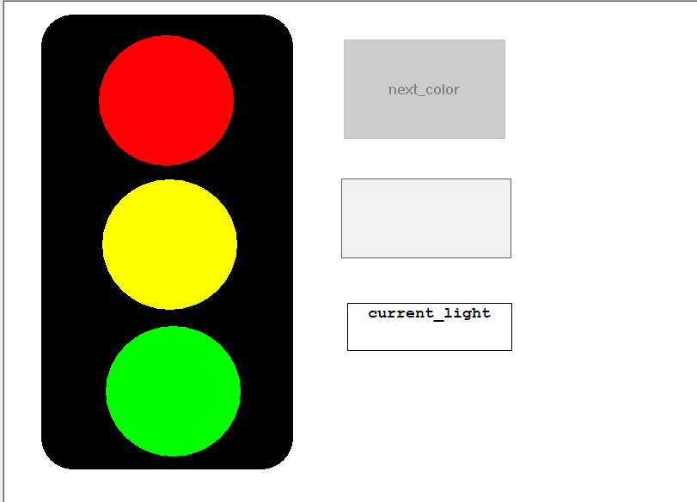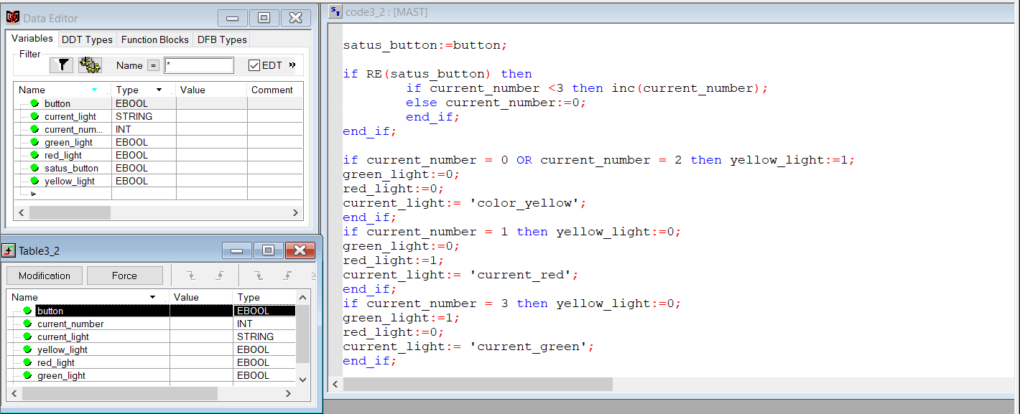

**Working Part:**

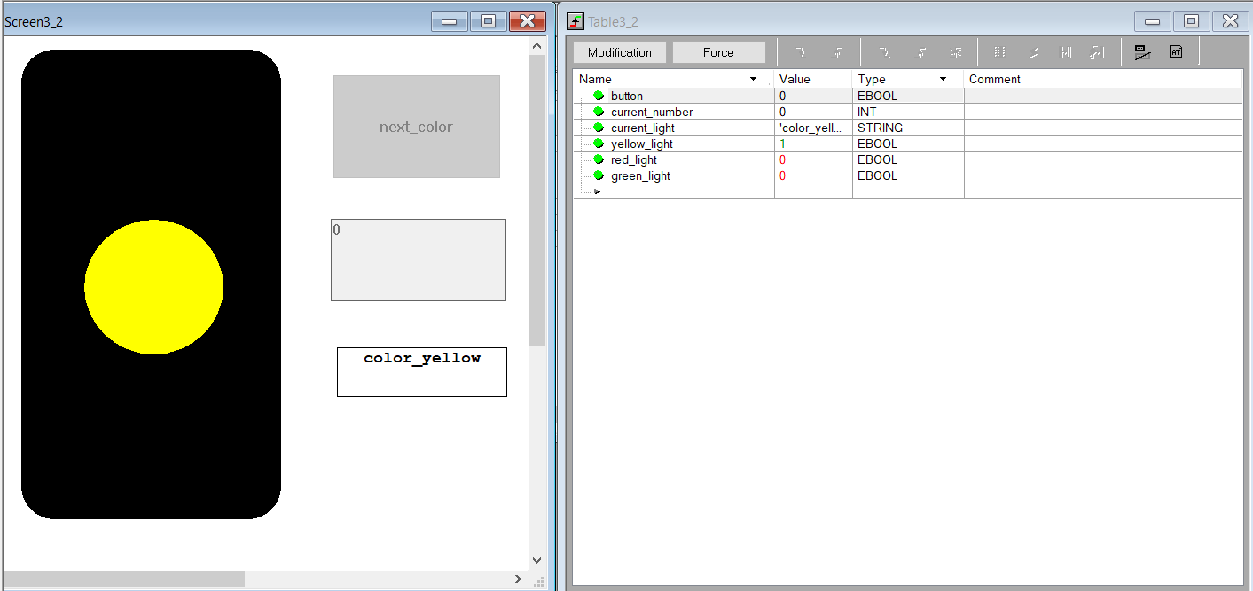

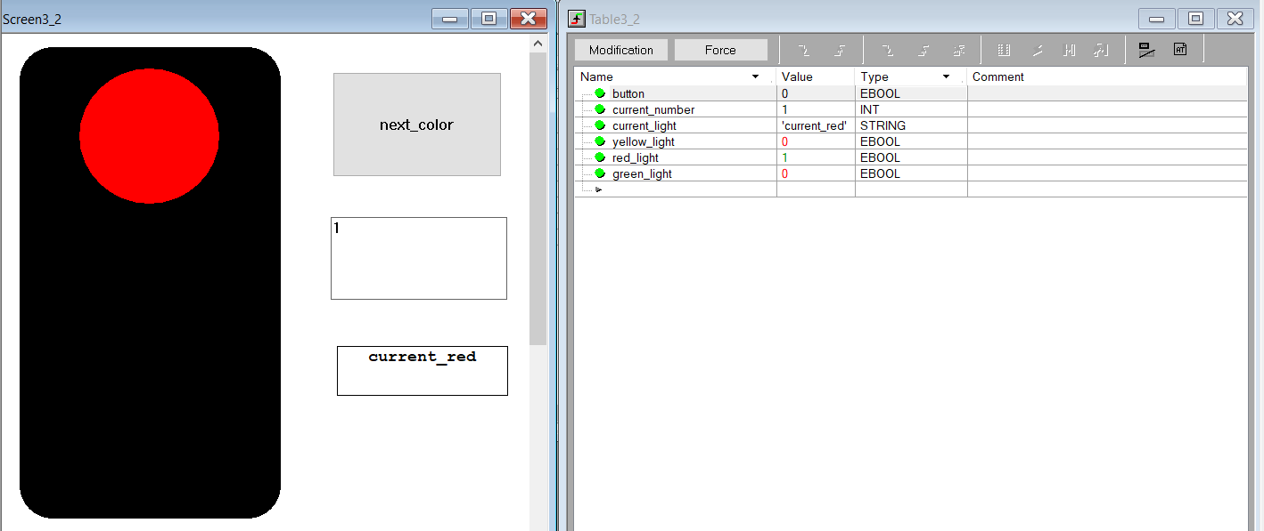

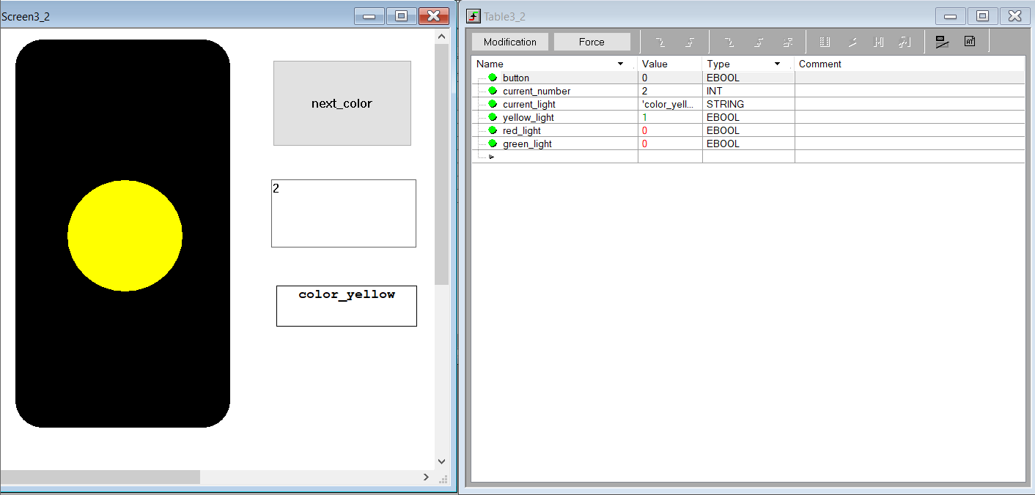

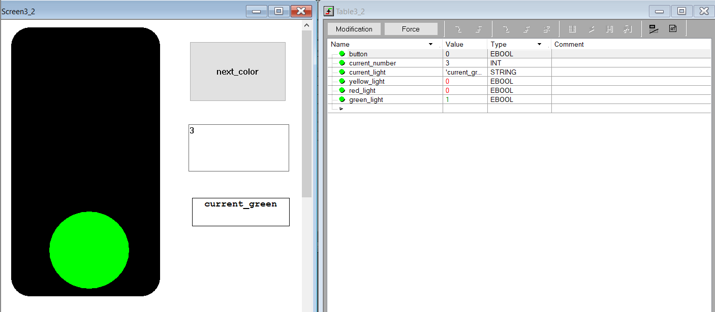**Task 3.3**

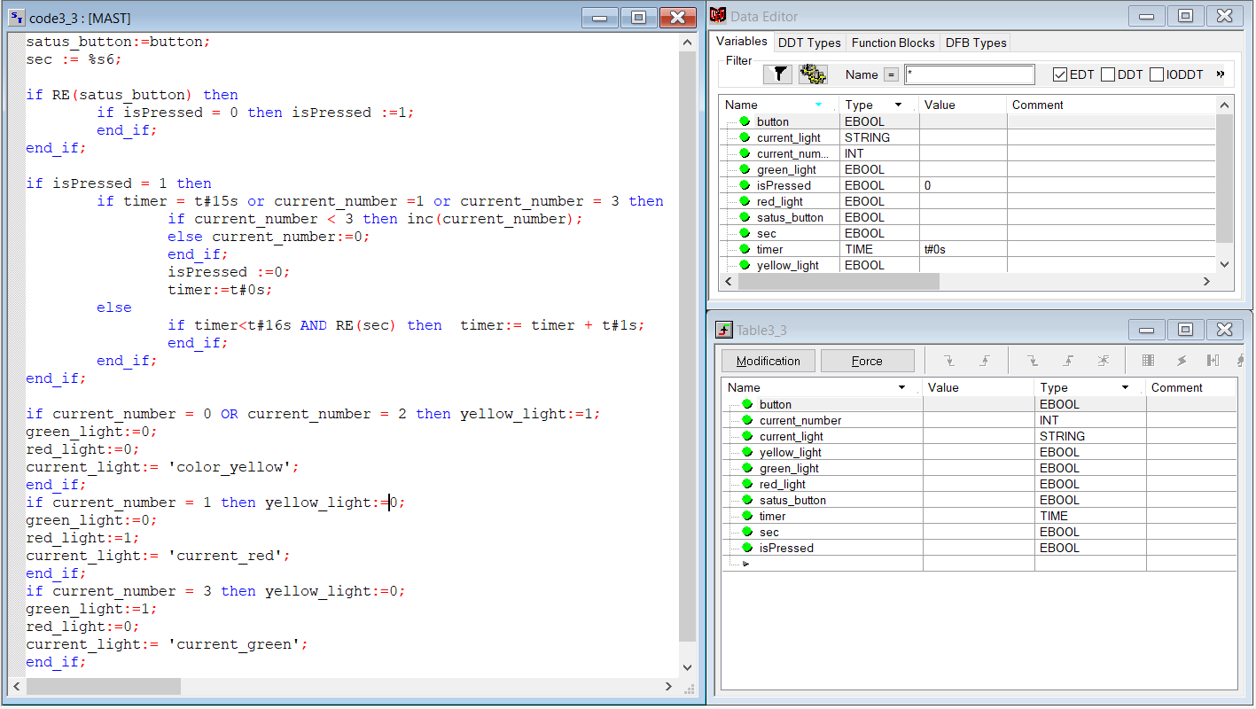It is necessary to complicate the task of switching traffic light colors at the press of a button by adding a time delay of 15 seconds after switching to red and green. When solving the problem, you can use any studied constructions of the ST language.

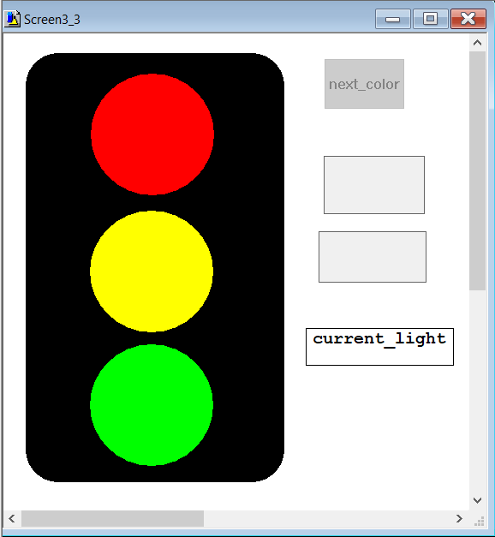

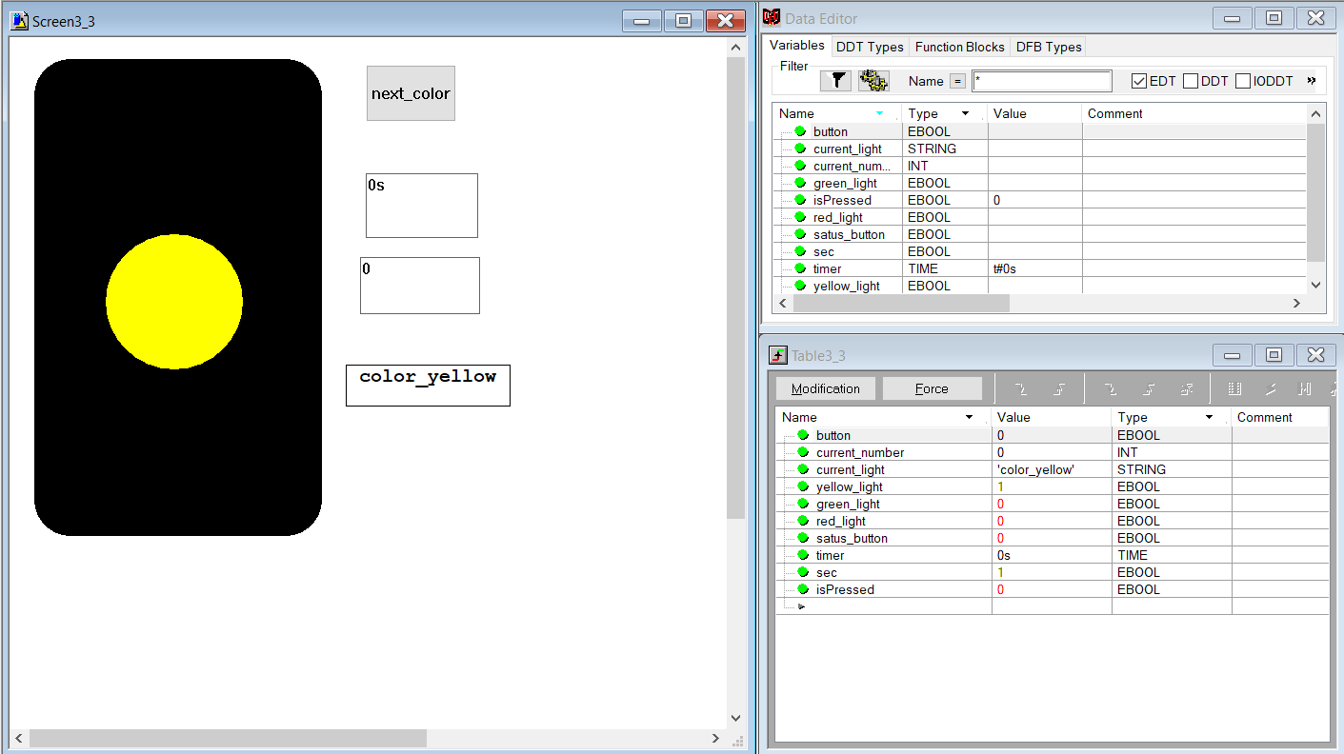**Working Part:**

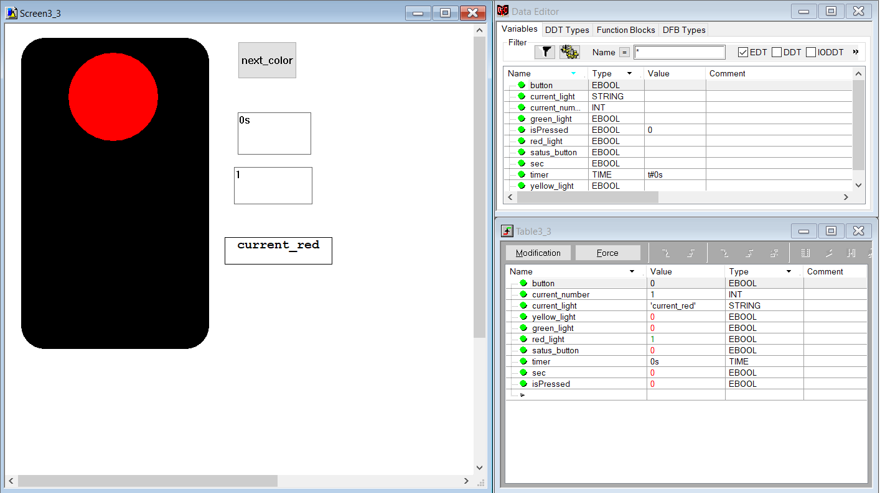

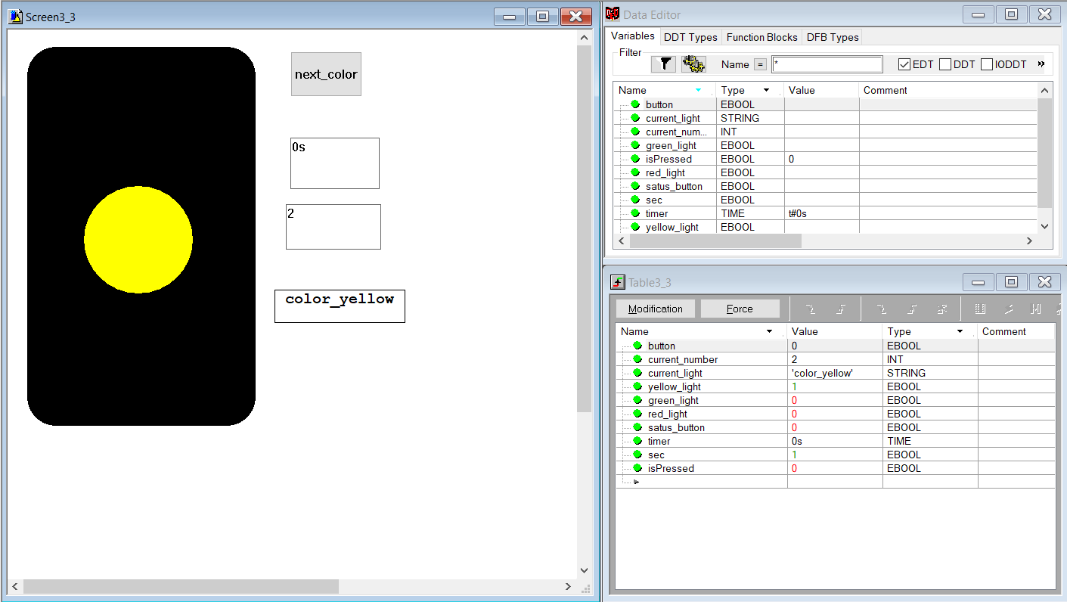

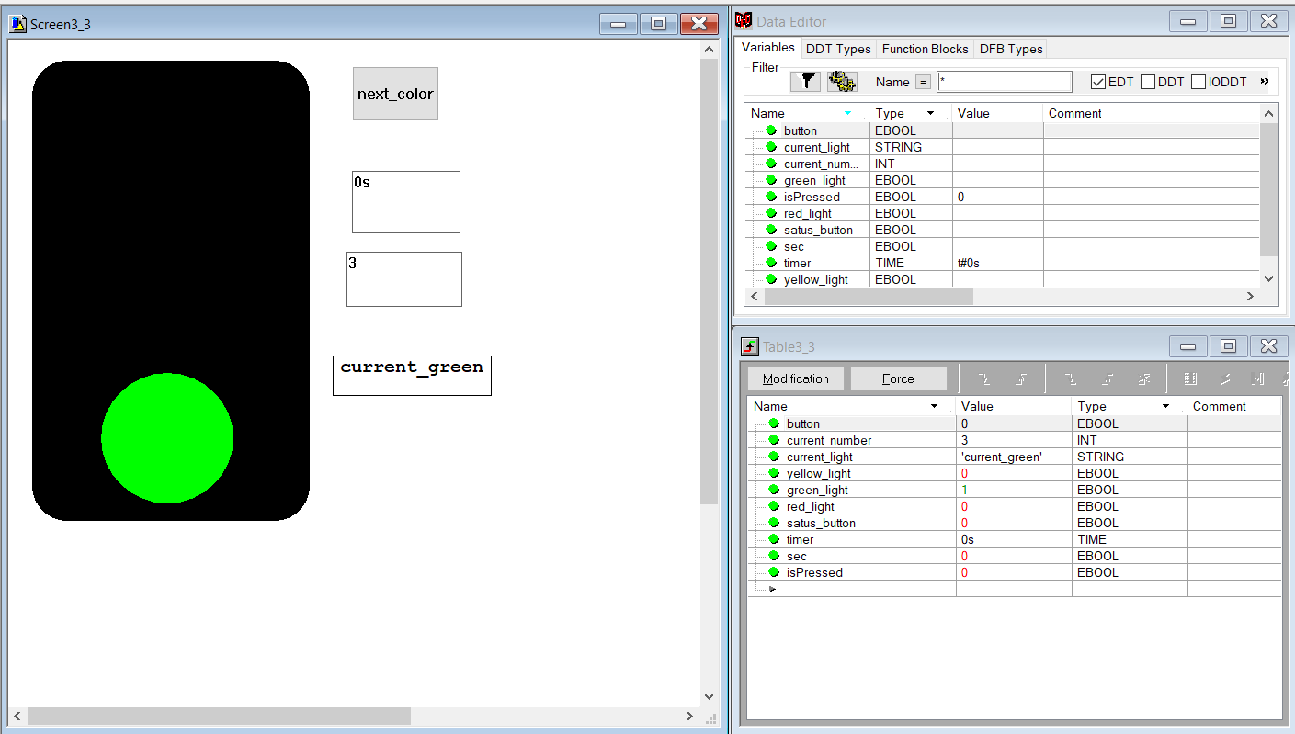

**Control Questions:**

1. What is the case..of..end_case construction used for?
2. How do I display text on the operator screen of Unity Pro?
3. What is the control variable used for?
4. What is the function of case instruction labels?
5. What types of variables can act as a selector when using the case..of..end_case instruction?
6. What is the UINT data type?
7. What is the UDINT data type?
8. What is the difference between signed and unsigned data types?

**Answers:**

1. The construction case..of..end_case used to perform one of the operations whose label is one of the selections. It works with about the same principle as if … elseif … end_if
2. To do this, add a string format variable. The text in the operator screen will be displayed using the TEXT component, which is assigned the value of a variable.
3. The control variable that was used int case..of..end_case and for if…elseif..end was variable ‘current_number’ that indicates which current light of the traffic light must be turned on.
4. The first group executes instructions whose label contains the computed selector value. Otherwise, none of the instructions will be executed. The OF instruction indicates the start of the label. An ELSE statement can be executed within a CASE statement, whose statements are executed if none of the labels contain a selector value.
5. Each group is provided with a label that consists of one or more integers:

- INT - signed integer type in 16-bit format;

- DINT - double integer, signed type in 32-bit format;

- UINT - unsigned integer type in 16 bit format;

- UDINT - unsigned double integer type in 32-bit format

1. UINT is the abbreviation of the Unsigned INTeger format (encoded in 16 bits). The upper/lower limits are as follows: 0 to (2 to the power of 16) - 1.
2. UDINT is the abbreviation of Unsigned Double INTeger (encoded in 32 bits). The upper/lower limits are as follows: 0 to (2 to the power of 32) - 1.
3. The main difference between signed and unsigned data types is that unsigned numbers can be only positive, but signed also negative. Since of that the range of possible variables is critically various.

**Conclusion**

During the third laboratory work we studied the